MUTHUR - Installation Guide for Local Test Server

- Go to http://www.oracle.com/technetwork/java/javase/downloads/index.html and download the JDK (Java Developers Kit).
- In Windows Explorer go to the directory to which the JDK was installed and go to the [INSTALLATION DIRECTOR]/JDK/JRE folder. Copy the address of this directory path.
- In the Start Menu, go to My Computer, right-click and select Properties.
- Go to the Advanced tab and select Environment Variables. Click New to create a new environment variable; set the name to be JAVA_HOME and the path to be the address copied in step 2.
- Unzip the LocalMuthurTestServer.zip file to the directory of your choice.
- Go to the bin folder and double-click the file “servicemix.bat”. You should see the following (allow several minutes for everything to load):
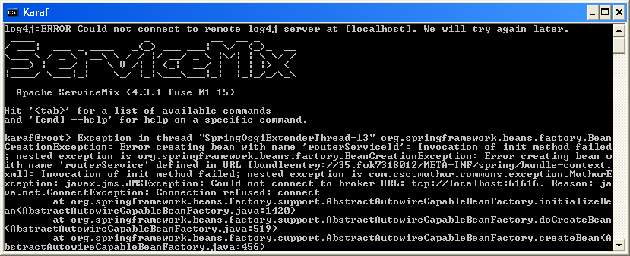
- After the startup has completed, hit Enter.
- Enter the command “list | grep uthur”. This should display a list of services containing the string “uthur” in the name (Each service should say Started next to it; if they all do not then manually stop and start the appropriate service as shown below):
